ST. PAUL'S LUTHERAN CHURCH
460 McBride Street, Prince Rupert, B.C
Office Phone: 624-4164 Email: stpauls@citywest.ca
Church Website: stpaulsprincerupert.com
Pastor: Diana S. Edis Home: 250 622-2725
Pastor’s email: pastor2stp@gmail.com

2nd Sunday of Pentecost June 19, 2022
Worship 11:00 A.M.

Minister: Rev. Diana Edis Musician: Larissa Goruk
Videographer: George Edis Reader: Pat Rogers

Worship is live streamed on our Facebook page: https://www.facebook.com/princerupertlutheran/.
You do not need a Facebook account to access worship.

Welcome to Worship with St. Paul's. On Pentecost, we celebrate that we have been given an Advocate to accompany us. Poured out in wind and fire, water, wine, and bread, the Holy Spirit abides in and among us. We give thanks that God speaks to each of us, no matter our origins, language, or life path. Filled with the Spirit of truth, we go out from worship to proclaim the saving power of Christ’s love and the freedom of God’s grace with all the world.

Weekly Prayer Petitions
Local Parishes: First United Church – Pastor Derry Bott
Synod Parishes: Shepherd of the Valley Lutheran in Comox
Anglican Joint Prayers: The Provincial Synod of the Ecclesiastical Province of Rupert’s land
Lutheran Joint Prayers: The National Indigenous Day of Prayer: for healing and reconciliation between Indigenous and non-Indigenous Peoples.
Discipleship Opportunities
1. The Pastor is Public, Javadotcup Wednesdays from 9:30 - 11:30AM. We are both in-person and on Zoom: https://us02web.zoom.us/j/87222984486?pwd=OHFIcWZySkR1dHNpeklqMzU4RlJWUT09
Meeting ID: 872 2298 4486 Password: 263906

2. The planning team for celebration of St. Paul’s 100th anniversary (2024) has met and the planning has begun. Please contact Larissa Goruk, Ellen Witherly, or Tom Kertes for more information.

* All Hymns and liturgical text reprinted under license from One License: license number A-731124 and Augsburg Fortress: license number SB157842 * Bible readings are taken from the New Revised Standard Version, covered under AF license number SB157842.
*******
Announcements

Thanksgiving for Baptism
Blessed be the holy Trinity, ☩ one God, whose steadfast love endures forever.
Amen.
Let us confess our sin in the presence of God and of one another.
Silence is kept for reflection.
Merciful God,
we confess that we have not followed your path but have chosen our own way. Instead of putting others before ourselves, we long to take the best seats at the table. When met by those in need, we have too often passed by on the other side. Set us again on the path of life. Save us from ourselves and free us to love our neighbors.
Amen.
Hear the good news! God does not deal with us according to our sins but delights in granting pardon and mercy. In the name of ☩ Jesus Christ, your sins are forgiven. You are free to love as God loves.
Amen.

Gathering Hymn Rise, Shine, You People No. 665

The grace of our Lord Jesus Christ, the love of God, and the communion of the Holy Spirit be with you all.
And also with you.

Kyrie Pg 184
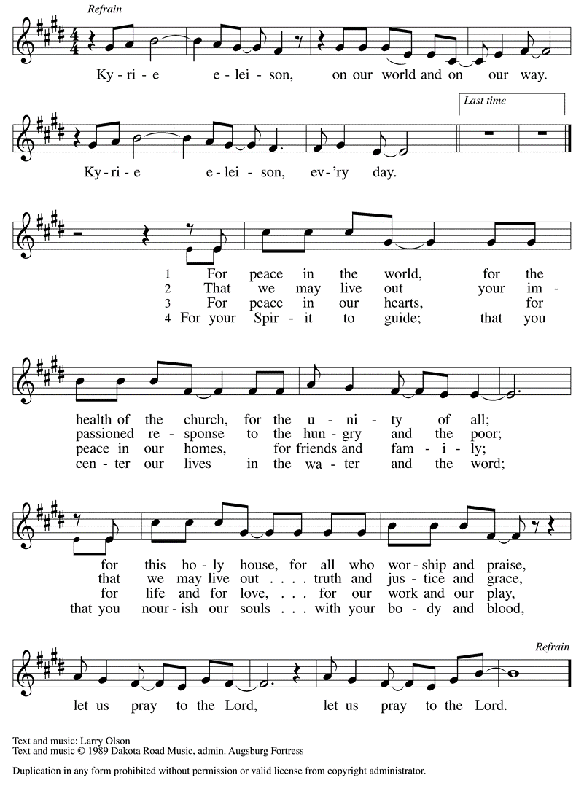

Prayer of the Day
O Lord God, we bring before you the cries of a sorrowing world. In your mercy set us free from the chains that bind us and with which we bind others. Defend us from everything that is evil, through Jesus Christ, our Savior and Lord. Amen.

Our first reading is from Isaiah, beginning at the 65th chapter 65:1-9

I was ready to be sought out by those who did not ask, to be found by those who did not seek me.
I said, “Here I am, here I am,” to a nation that did not call on my name. I held out my hands all day long
to a rebellious people, who walk in a way that is not good, following their own devices; a people who provoke me to my face continually, sacrificing in gardens and offering incense on bricks; who sit inside tombs, and spend the night in secret places; who eat swine’s flesh, with broth of abominable things in their vessels; who say, “Keep to yourself, do not come near me, for I am too holy for you.” These are a smoke in my nostrils, a fire that burns all day long. See, it is written before me: I will not keep silent, but I will repay; I will indeed repay into their laps their iniquities and their ancestors’ iniquities together,
says the Lord; because they offered incense on the mountains and reviled me on the hills, I will measure into their laps full payment for their actions. Thus says the Lord: As the wine is found in the cluster, and they say, “Do not destroy it, for there is a blessing in it,” so I will do for my servants’ sake, and not destroy them all. I will bring forth descendants from Jacob, and from Judah inheritors of my mountains;
my chosen shall inherit it, and my servants shall settle there.

L: The word of the Lord,
C: Thanks be to God

We read Psalm 22:19-28 responsively: (leader reads the light print, congregation reads the bold)
But you, O Lord, be not far away; O my help, hasten to my aid.
Deliver me from the sword, my life from the power of the dog.
Save me from the lion’s mouth! From the horns of wild bulls you have rescued me.
I will declare your name to my people; in the midst of the assembly I will praise you.
You who fear the Lord, give praise! All you of Jacob’s line, give glory.
Stand in awe of the Lord, all you offspring of Israel.
For the Lord does not despise nor abhor the poor in their poverty;
neither is the Lord’s face hidden from them; but when they cry out, the Lord hears them.
From you comes my praise in the great assembly;
I will perform my vows in the sight of those who fear the Lord.
The poor shall eat and be satisfied, Let those who seek the Lord give praise!
May your hearts live forever!
All the ends of the earth shall remember and turn to the Lord;
all the families of nations shall bow before God.
For dominion belongs to the Lord, who rules over the nations.

Our second reading is from Galatians beginning at the 3rd chapter 3:23-29

Now before faith came, we were imprisoned and guarded under the law until faith would be revealed. Therefore the law was our disciplinarian until Christ came, so that we might be justified by faith. But now that faith has come, we are no longer subject to a disciplinarian, for in Christ Jesus you are all children of God through faith. As many of you as were baptized into Christ have clothed yourselves with Christ. There is no longer Jew or Greek, there is no longer slave or free, there is no longer male and female; for all of you are one in Christ Jesus. And if you belong to Christ, then you are Abraham’s offspring, heirs according to the promise.

L: The word of the Lord,
C: Thanks be to God

Gospel Acclamation page 188
The holy gospel according to Luke, beginning at the 8th chapter 8:26-39

Glory to you, O Lord

Then [Jesus and his disciples] arrived at the country of the Gerasenes, which is opposite Galilee. As he stepped out on land, a man of the city who had demons met him. For a long time he had worn no clothes, and he did not live in a house but in the tombs. When he saw Jesus, he fell down before him and shouted at the top of his voice, “What have you to do with me, Jesus, Son of the Most High God? I beg you, do not torment me”—for Jesus had commanded the unclean spirit to come out of the man. (For many times it had seized him; he was kept under guard and bound with chains and shackles, but he would break the bonds and be driven by the demon into the wilds.) Jesus then asked him, “What is your name?” He said, “Legion”; for many demons had entered him. The (demons) begged him not to order them to go back into the abyss.
Now there on the hillside a large herd of swine was feeding; and the demons begged Jesus to let them enter these. So he gave them permission. Then the demons came out of the man and entered the swine, and the herd rushed down the steep bank into the lake and was drowned.
When the swineherds saw what had happened, they ran off and told it in the city and in the country. Then people came out to see what had happened, and when they came to Jesus, they found the man from whom the demons had gone sitting at the feet of Jesus, clothed and in his right mind. And they were afraid. Those who had seen it told them how the one who had been possessed by demons had been healed. Then all the people of the surrounding country of the Gerasenes asked Jesus to leave them; for they were seized with great fear. So he got into the boat and returned. The man from whom the demons had gone begged that he might be with him; but Jesus sent him away, saying, “Return to your home, and declare how much God has done for you.” So he went away, proclaiming throughout the city how much Jesus had done for him.

L: The gospel of the Lord.
Praise to you, O Christ.

Sermon Rev. Diana Edis

Hymn of the Day Praise the One Who Breaks the Darkness No. 843

Apostle’s Creed Pg 105
Living together in trust and hope, we confess our faith using the words of the Apostles’ Creed. We confess:
I believe in God, the Father almighty, creator of heaven and earth.
I believe in Jesus Christ, God's only Son, our Lord, who was conceived by the
power of the Holy Spirit, born of the Virgin Mary, suffered under Pontius Pilate, was crucified, died, and was buried; he descended to the dead. On the third day he rose again; he ascended into heaven, he is seated at the right hand of the Father, and he will come to judge the living and the dead.
I believe in the Holy Spirit, the holy catholic Church, the communion of saints,
The forgiveness of sins, the resurrection of the body, and the life everlasting. Amen

Prayers of Intercession: (petition end: God of grace,)
(petition response: hear our prayer.)

L: The peace of Christ be with you always.
And also with you.

Offering
Offerings may be mailed to the church or placed in our mailbox or you can send e-transfers to offering2stpauls@citywest.ca. You may also give through CanadaHelps to St. Paul’s Lutheran, Prince Rupert.

Offering Prayer
God of abundance: you have set before us a plentiful harvest. As we feast on your goodness, strengthen us to labor in your field, and equip us to bear fruit for the good of all,
in the name of Jesus.
Amen.

We enter a time of communion. All people are invited to receive God’s meal. If you wish to receive, this meal is for you. If you would like to learn more about communion please contact the pastor after worship. Those at home may prepare bread and wine or juice for your worship space. When the bread and beverage are offered by the pastor and you eat and drink you may respond, “Amen.” Those worshipping online in the same household are encouraged to serve one another.

The Lord be with you.
And also with you.
Lift up your hearts.
We lift them to the Lord.
Let us give thanks to the Lord our God.
It is right to give our thanks and praise.

It is indeed right… we praise your name and join their unending hymn:

Holy, holy, holy pg 190

In the night in which… we prepare our hearts for your presence.
Come, Holy Spirit. Come, Holy Spirit. Amen

L: Gathered into one across time and space by the Holy Spirit, let us pray as Jesus taught us, using whatever version of that prayer comforts you. We pray:
Our Father in heaven, hallowed be your name,
your kingdom come, your will be done, on earth as in heaven.
Give us today our daily bread.
Forgive us our sins as we forgive those who sin against us.
Save us from the time of trial and deliver us from evil.
For the kingdom, the power, and the glory are yours,
now and forever. Amen.
L: If the Holy Spirit calls you to this feast of bread and wine or juice, I invite you to receive that which has been prepared, each in our own places, but gathered together around the table of God. Although we are separated at this time by physical distancing, we are united, made whole in the body of our Lord. The risen Christ dwells with us here. All who are hungry, all who are thirsty, come.

Lamb of God pg 191
Communion
Hymns during Communion No. 1062, 496 (Red)

The body and blood of our Lord and Saviour strengthen you to eternal life.
Amen

Let us pray: Life-giving God, through this meal you have bandaged our wounds and fed us with your mercy. Now send us forth to live for others, both friend and stranger, that all may come to know your love. This we pray in the name of Jesus.
Amen.

Blessing
The God of peace, Father, ☩ Son, and Holy Spirit, bless you, comfort you, and show you the path of life
this day and always.
Amen.

Sending Hymn The Church of Christ in Every Age No. 729

Sending
L: Go in peace. Love your neighbor. C: Thanks be to God.

